Summary for pre-read

WBR - Summary (for Pre-Read)

1) DLD Market
Overall market transaction value slightly improved vs last week, driven more by Primary than Secondary. However, leading indicators including Form F and Rentals remain at similar levels vs pre-conflict levels, suggesting no major sentiment improvement (or even further deterioration in market).
2) Commercial
Sales Forecast: AED 46.1M vs 70.6M target (65% FC for March, upside to 68%). Continuation of hostilities resulting in more downside and reducing upside. Similar levels expected for April. Concerns around cashflow remain top of client minds.

3) Demand
SoS: Overall SoS at 50.2% (-4.4pp vs 54.6% target, +0.3pp WoW). Web SoS at 48.3% (-2.1pp vs 50.4% target, -1.4pp WoW). App SoS at 51.6% (-2.0pp vs 53.6% target, +1.5pp WoW).
SEO SoV: Total at 45.8% (+0.5pp WoW). Buy 62.7% (-0.3pp WoW); Rent 53.1% (-0.7pp WoW). Generic 32.9% (+0.2pp WoW).
PR SoV: 88% MtD (target 50-55%), firmly in green.
4) Data Governance
Data challenges continue due to Kochava vs Redshift, GA4 vs Redshift. Solution needs to be prioritized
5) New Projects (Primary)
New Projects gross revenue ($132.8K) back in green at 102% of weekly target (+19.3% WoW). Recovery mostly driven by price — fewer leads to distribute, clients bidding higher. No panic observed.
Media & Developers: Forecast at 31%. New budgets on hold until further notice. $0.8M in upside would bring achievement to 59% for March.

6) B2C App
App DAU at 50.9K (+17% WoW), recovering from prior week dip. WAU at 185.5K (flat WoW).
App rating: Both android (4.16) and iOS (4.69) App ratings are under targets
7) B2C Tech
Mobile INP Good Rate reached 72.0%, meeting the 72% target (+2.5pp WoW).
App stability: Green. Android Apdex and iOS Apdex both above 95% threshold in the latest data
8) B2B Performance
Incident Volume: March continues with the lowest incident volume ever recorded — 17 tickets MtD (16 P1s + 1 P0). Weekly: P0: 0 (vs 6 target), P1: 3 (vs 73 target).
B2B Agent App: App active agents at 11,341 (-16.5% vs 13,597 target, +1.2% WoW). WAU at 3,203 (-33.4% vs 4,811 target, +9.3% WoW). Both metrics remain under target.
9) Listing Quality
DLD violations reduced by 30%. Working with BA on additional metrics for fake listings (timeline: end of week). Actions planned: Locations mandation (ETA: 26th March), Size mandation, Republish prevention (ETA: 31st March), Fake listings with extreme prices auto clean-up.

DLD Market Growth

Property Finder
Weekly Business Review

Market (Dubai)
Overall market tx. value, slightly improved vs last week - driven more by Primary (vs Secondary). Yet leading indicators including Form F and Rentals remain at similar levels vs pre-conflict levels, suggesting no major sentiment improvement (or even further deterioration in market).

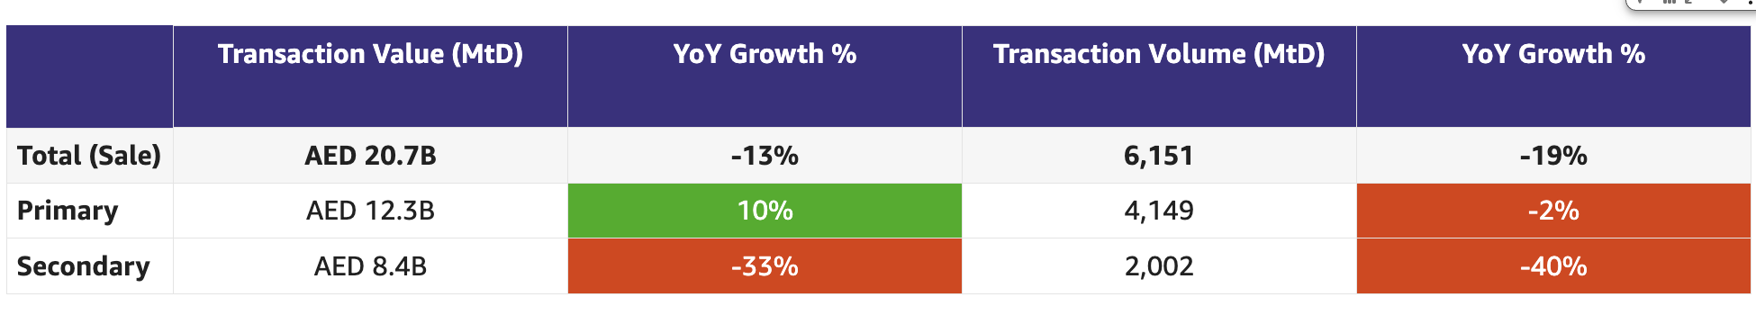

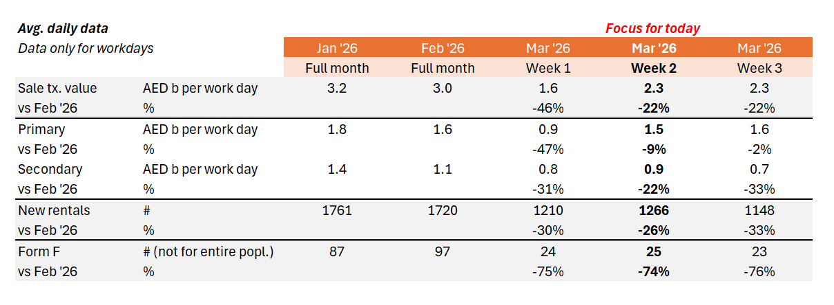

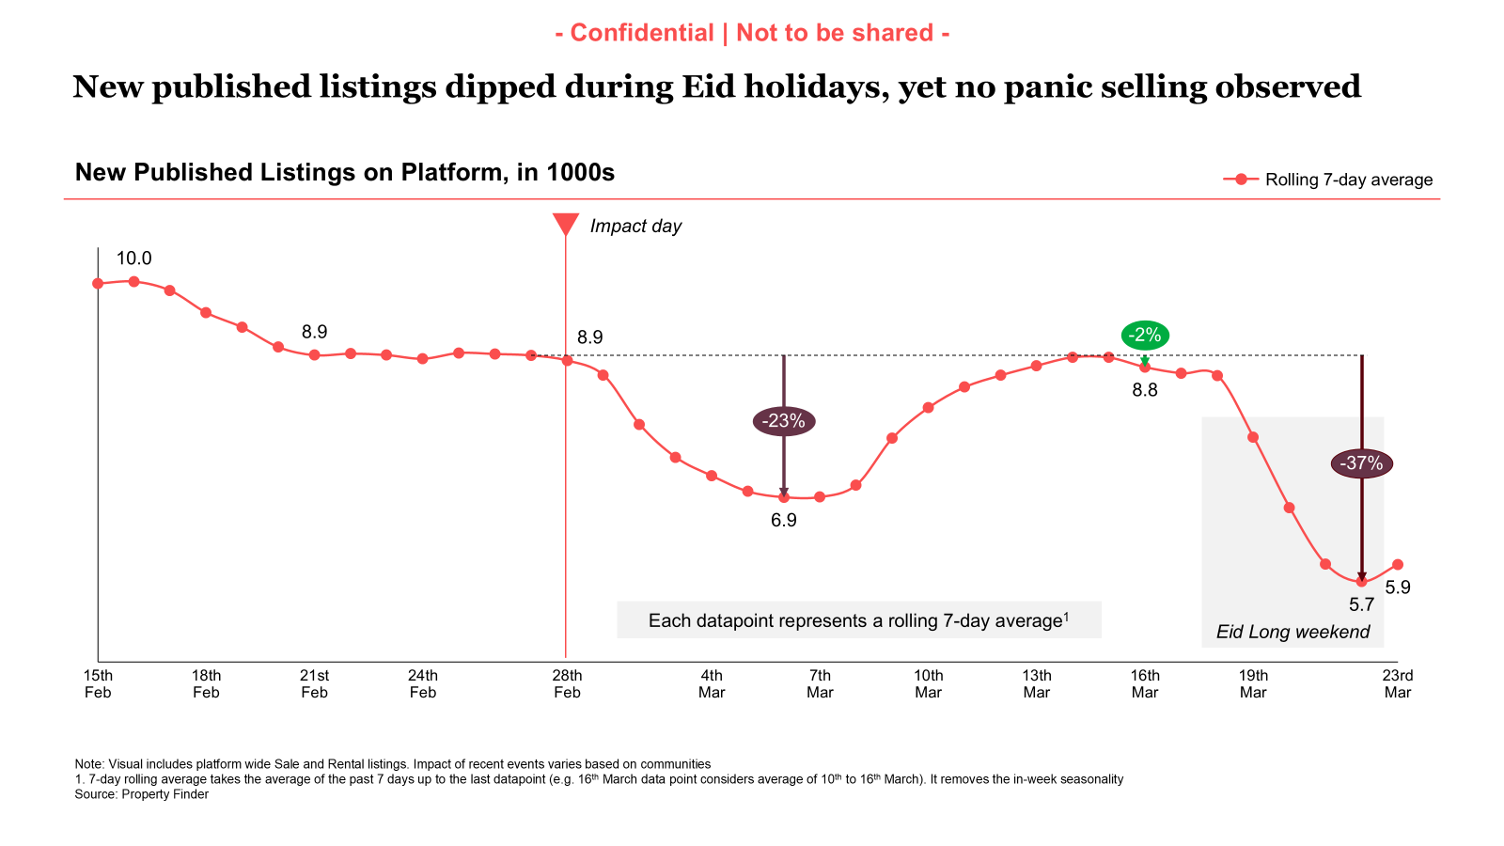

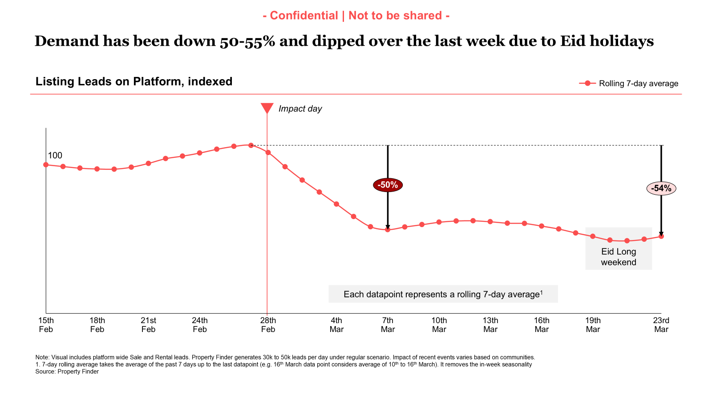

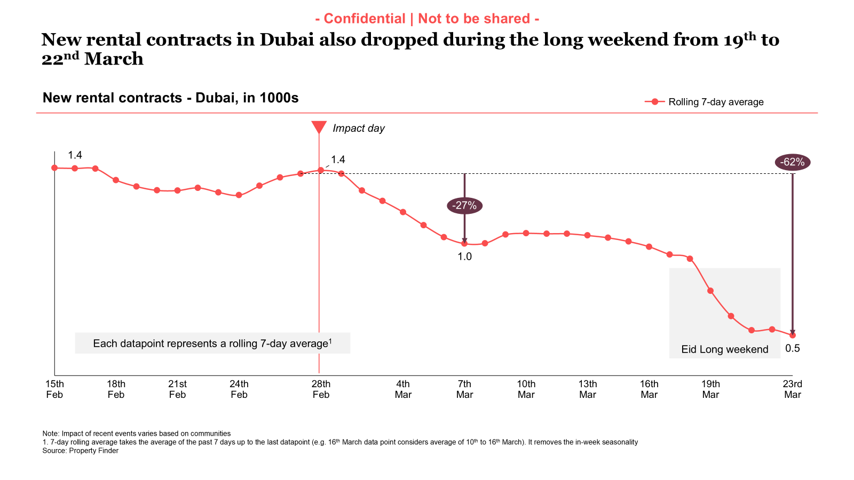
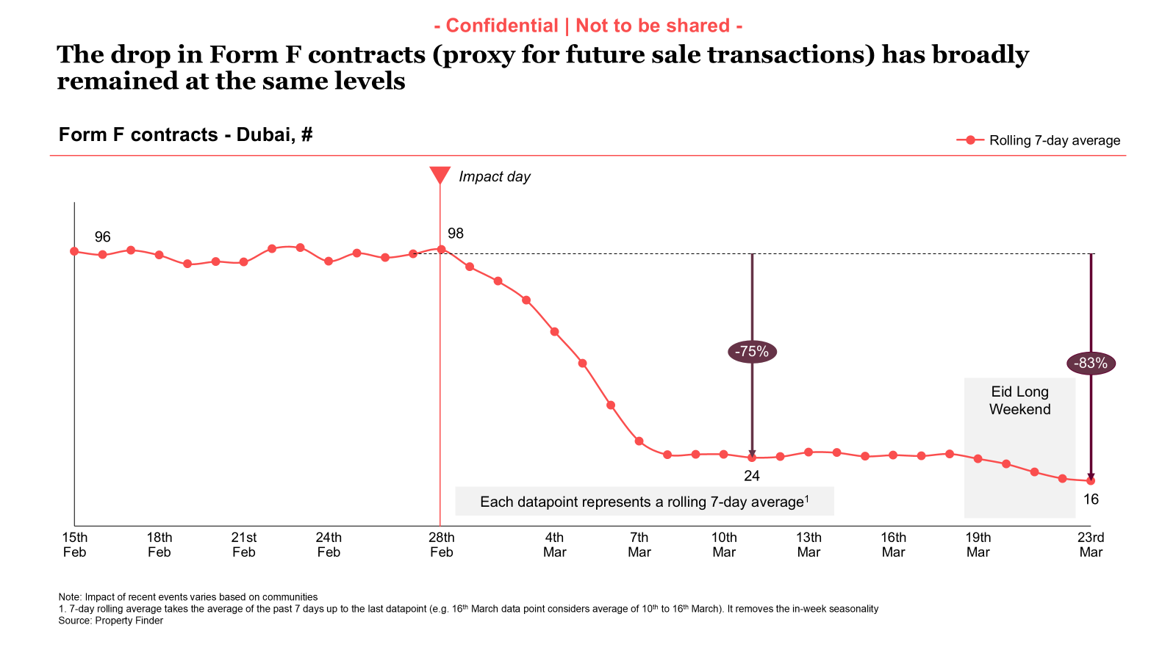

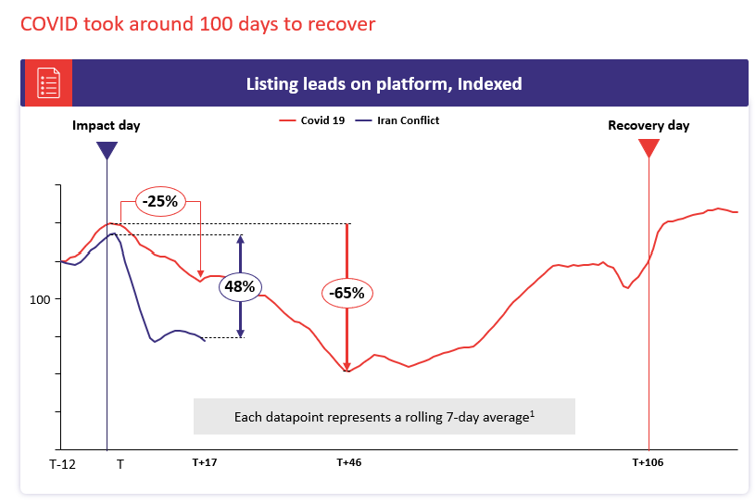

Commercial

Commercial
Category | DRI | Which metric is red and why | Actions planned | ETA for target achievement
Sales forecast % | Vladimir Malugin | March previous view: 95% (with upside to 101%)  CURRENT VIEW:  65% FC for March (upside to 68%) - sales have identified main risks. Similar levels for April.  Continuation of hostilities is resulting in more downside and reducing upside. Concerns around cashflow for next few months are still top of client minds | Continued focus through following initiatives, while recognizing key risks:  - Account Plans  - Renewal Narratives  MITIGATION:  - March Relief - in action  - Eid Relief packages - just announced at the Commercial Town Hall today - client meetings starting NOW  - Anti-crisis broker playbook - shared with BC:  - Leads and deals are not gone - there is less  - Time to nurture them more to close in 2-3 months  - If you are not in the market - you are not competing for sellers and buyers that are here
Exclusive Listings | Michelle Brackley | Targets set using baseline data from 3rd march (1.4 x CLEL)  Clean up of ORN led to an increase in Net exclusive listings of 4,021.  PF currently has 1.95 X the exclusive listings on Bayut. | - Community ranking Methodology  Owners: Yash/Volkan  Next Steps: Exclusive listings will be incorporated into the ranking methodology for "Top Communities"  ETA: 17/03/26  - CPL discount on BY Exclusive listings  Owner: Anirudh  Next steps: Update on this needed  - Automatic import of BY Exclusive Listings  Owners: Hugs  Next Steps: Training session to be set up with BCs & CSPs  ETA: TBC  Go live: 26/03/26  - Milestone Driven Benefits  Owner: Hugs  Next Steps: Initial Proposal  ETA: 26/03/26  - Align on Communities to target for performance marketing campaigns:  Owners: Mahmoud/Michelle  Next steps: Meeting set up  ETA: 25/03/26  - Compass & data narrative:  Owner: Aksinia  Next steps: rolled out  ETA: 26/03/26  - Collateral for pitching to Bayut exclusive clients:  Owners: Michelle / Pascal  Next steps: Agree on what is needed  ETA: 3/04/26  - Non-compliant listings:  Alignment on communication flow.  Implementation being planned  ETA - .

Weekly Metrics
 |  | Weekly |  |  |  | MTD (Feb)
Category | Metric | Week  (Actual) | Week (Target) | WoW | vs 2 weeks prior | MtD  (Forecast) | Month (Target) | vs MtD  prev month (MoM) | vs MtD  prev year (YoY) | vs competition | DRI | Dash
Sales  (MtD) - UAE | Sales Forecast %  (Month-end) | Monthly -> |  |  |  | 46.1M  (65%) | 70.6M | Not Applicable | Not Applicable | Not Applicable | Vladimir Malugin | Link

CLEL to not be discussed in Q1, till baseline is defined and Product actions are in place

Category | Metric | Week  (Actual) | Week (Target) | WoW | vs 2 weeks prior | MtD  (Actual) | Month  (Target) | vs MtD  prev month (MoM) | vs MtD  prev year (YoY) | vs competition | DRI | Dash
Net exclusive listings | Rent | 12.1K | NA | (+4.9k)  7.2K | (+8.9K)  5.2K | NA | NA | NA | NA | Not Applicable | Michelle Brackley
 | Sale | 12.2K | NA | (-0.9k)  13.1K | (+1.1K)  11.1K | NA | NA | NA | NA | Not Applicable | Michelle Brackley
Supply | Net Exclusive Listings | 24.3K | NA | (+4K)  20.3k | (+8K)  16.3K | NA |  | NA | NA | Not Applicable | Michelle Brackley

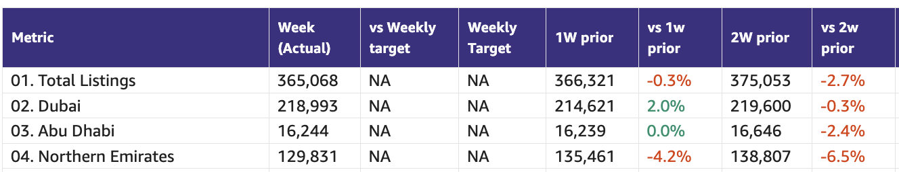

Primary (NP, Media, Dev)

Primary (New Projects, Media Sales)
Category | DRI | Which metric is red and why | Actions planned | ETA for target achievement
New Projects | Enguerran Milhiet | - Revenue back in green, however mostly driven by price: less leads to distribute, clients are fighting for leads > higher bidding.  - Demand (sessions, sold leads) metrics still in red, back to October 2025 levels.  - Still no panic observed, | Similar to last week.  - Continue SEO initiatives (footer content in the developer list, update project description with SEO-friendly keywords, revisit META Title/Description content, Internal Links) => impact on sessions and leads  - Launch smart leads => impact on sold leads (conversion)  - Halt on price changes to avoid any misperception from clients. | - Expected to achieve 90% of Primary Plus revenue in March.
Media & Developers | Sami Awada | - The forecast is at 35%. New budgets are on hold until further notice | - Focus on active campaigns and push delivery | - 0.8M in upside would bring achievement to 59% for March.

Category | Metric | Week  (Actual) | Week (Target) | WoW | vs 2 weeks prior | MtD  (Actual) | Month  (Target) | vs MtD  prev month (MoM) | vs MtD  prev year (YoY) | vs competition | DRI | Dash
New Projects | Sessions | 58.9k | 87k | +36.1% | -13.6% | 106k | 385,454 | -37.9% | -52.3% |  | Enguerran Milhiet
 | Sold Leads | 1,486 | 1,787 | +39.3% | -26.8% | 2,683 | 7,910 | -29.2% | +17.4% |  | Enguerran Milhiet
 | Gross Revenue (USD) | $132.8k | $130.6k | +19.3% | -30.7% | $256k | $578.2k | -24.7% | +37.4% |  | Enguerran Milhiet
Media & Developer | Revenue from Media Products | NA | NA | NA | NA | Monthly |  |  |  |  | Sami Awada

Demand (Paid/Unpaid)

Demand
Category | DRI | Which metric is red and why | Actions planned | ETA for target achievement
Paid | Ahmed Osman | - No internal data reported. | Summary (22 Mar 2026):  - Demand: Sessions index is currently 67 (baseline = 100), 33pts below baseline with WoW at -12.7%. The decline is driven by Eid al-Fitr seasonality (Mar 20 onward). Pre-Eid (as of Mar 19), WoW was already softening at -2.3%, confirming the scaling experiment did not produce a demand uplift. We're tracking pull channels only (organic search, paid search, and app sessions).  - Primary Demand: We’re capturing more sellable leads through our paid campaigns (MtD +92% MoM), likely due to reduced competitor activity.  - Spend: Pre-conflict spend averaged $34.5K/day. The last 7-day average is $28.1K/day (-18% vs pre-conflict). We have scaled down bids on buy campaigns after the scaling experiment showed no improvement in conversion efficiency.  - Leads: Both channels are declining. Organic leads WoW at -26.8%, Paid leads WoW at -37.4%. This is consistent with the Eid demand dip and should not be read as a structural reversal.  - Competitive: Paid search SOV remains strong. Core Buy at 63% and Core Rent at 78%, consistently above 50% for 14+ straight days. We also observed Bayut pulling out of international search campaigns across India, UK, and US, markets where they were historically active.  Next Steps:  - Bid Optimization: Buy campaign bids have been scaled down following the experiment. We will maintain current levels through the Eid period and reassess once demand normalizes (expected post Mar 30).  - Messaging: BAU catalog ads continue alongside transaction-focused messaging targeting users tracking price movements in the current market.  - International Opportunity: With Bayut inactive in key source markets, we're evaluating whether to expand share of voice in India, UK, and US search at lower CPCs.  - Paid Search SOV: Continue holding our position on core keywords (e.g., "apartments for rent in Dubai", "buy property in Dubai") where we currently lead Bayut on both impression share and absolute top rate. | - N/A
Unpaid - SEO | Mahmoud Nessim | - Buy SoV, due to discrepancies with the tool, | - We’re working on a solution for the accurate and comprehensive measurements of SoV ( We won’t stop reporting the current SoV until we have the new one )  - As BAU, and continuation of our initiatives we’ve:  - SERP Revamp & footer content automation  - PLP, New Projects, and SERPs UGC widgets  - Capturing UGC ( so far > 130 reviews captured )  - Internal links from the blogs to keep the positive trend towards the SoV  - SoS increasing by bridging the gap between us and Bayut on the rental Listings ( SoL ) on key communities ( being handled with Michelle Brackley& Ahmed Osman for a plan of incentive )  - We’re working on having a better representation of rankings on app store ( ASO ) to be presented in the next WBRs* | - N/A
Unpaid - Overall | Soumar Aoun | N/A | Shipping this week (structural impact)  • SERP Revamp  Rolled back last week due to SEO impact. Fixes are in place and we’re planning to re-ship this week.  • Save Alert Notifications  Enhancements to improve engagement and drive more returning sessions.  • Search Re-engagement – Email Revamp (27/03)  Updated email journeys to improve relevance and drive higher CTR and re-engagement.  • 3D Floor Plan on PLP (Apps)  Shipping this week to enhance listing visualization and improve user decision-making.  Ramped Down → Shipping next week (CRM)  • City-level Search Re-engagement  Initially launched on 17/03 and scaled down to refine recommendation quality.  The previous logic was too broad (city-level suggestions), so we are shifting to more personalized recommendations based on user behavior and listings viewed.  Relaunch planned by 03/04 with improved targeting before scaling again. | N/A
Exposure LPL | Paresh Goyal | - NA | - NA as data not available yet | - Q2 eLPL targets to be reset, timeline delayed due to ongoing situation (tentative Mid April) - Ashish  - Product team progressing on CRM-led interventions, which is planned to go live on 30th March (Push & Email rollout).

1. SoV - SEO

Metric | Week (Actual) | 1W prior | vs 1W prior | 2W prior | vs 2W prior | MtD (Actual) | MtD PM | vs MtD PM
Total | 45.8% | 45.3% | 0.5 | 41.4% | 4.3 | 45.3% | 41.5% | 3.8
Buy | 62.7% | 63.0% | -0.3 | 63.7% | -0.9 | 62.2% | 67.2% | -4.9
Rent | 53.1% | 53.8% | -0.7 | 46.7% | 6.4 | 53.0% | 48.6% | 4.4
Generic | 32.9% | 32.7% | 0.2 | 30.4% | 2.5 | 32.7% | 28.3% | 4.3

2. Share of Sessions

Platform | This week | Mar target | Last week | vs last week | 2 weeks | vs 2 weeks | MTD | Last month | vs last month | Last year | vs last year
Total | 50.2% | 54.6% | 49.9% | 0.3 | 50.7% | -0.4 | 50.2% | n/a |  | 55.8% | -5.6
Web | 48.3% | 50.4% | 49.7% | -1.4 | 50.4% | -2.2 | 48.3% | 50.8% | -2.4 | 54.7% | -6.4
App | 51.6% | 53.6% | 50.1% | 1.5 | 50.8% | 0.8 | 51.5% | n/a |  | 57.3% | -5.8
MoM comparison for App & Total SoS is removed as it had data anomaly issues

App

Device category | This week | Mar target | Last week | vs last week | 2 weeks | vs 2 weeks | MTD | Last month | vs last month | Last year | vs last year
IOS | 48.9% | n/a | 48.3% | 0.6 | 50.1% | -1.2 | 48.8% | n/a |  | 50.6% | -1.8
Android | 53.4% | n/a | 51.4% | 2.0 | 51.2% | 2.1 | 53.2% | n/a |  | 61.5% | -8.2
MoM comparison is removed as it had data anomaly issues

App DAU

Device category | This week | Mar target | Last week | vs last week | 2 weeks | vs 2 weeks | MTD | Last month | vs last month | Last year | vs last year
App (Total) | 51.8% | n/a | 52.7% | -0.9 | 58.1% | -6.3 | 51.6% | n/a |  | 53.9% | -2.3
IOS | 48.6% | n/a | 49.5% | -0.8 | 54.8% | -6.2 | 48.5% | n/a |  | 46.6% | 1.9
Android | 53.8% | n/a | 54.8% | -1.0 | 60.2% | -6.3 | 53.6% | n/a |  | 58.2% | -4.6
MoM comparison is removed as it had data anomaly issues

3. Demand Funnel
(Direct and SEO Data are currently being fixed under Data Governance Workstream)

Web - Paid

App - Total

Exposure LPL
(EXCLUDES DIRECT)

Leads and Listings distribution

Rent vs Buy Split

Monthly Metrics

B2C NPS
Category | Metric | MtD  (Actual) | Month (Target) | vs MtD  prev month (MoM) | vs MtD  prev year (YoY) | vs competition | DRI | Dash
B2C NPS | B2C NPS | 4 | Not Available | 3 | 19 | Not Available | Alson Dsouza

Leads click to delivered:
Category | Metric | MtD  (Actual) | Month (Target) | vs MtD  prev month (MoM) | vs MtD  prev year (YoY) | Δ vs Competition | DRI | Dash
Leads Funnel | Total Leads Delivered (WA) |  |  |  |  | Not Available | Soumar AounSruthi Poduval | Link
 | % Clicks to Delivered (WA) |  |  |  |  | Not Available | Soumar AounSruthi Poduval | Link
 | Error Leads (WA) |  |  |  |  | Not Available | Soumar AounSruthi Poduval | Link

PR Metric
Category | Metric | MtD  (Actual) | Month (Target) | vs MtD  prev month (MoM) | vs MtD  prev year (YoY) | vs competition | DRI | Dash
PR | PR Sov | 78% | 50-55% |  | [...] | [...] | Natalie Faulkner | PR team

- Competition
  - Share of Session (Overall, Web Channels, App Channels)
  - SoV - Paid click share

- Demand Funnel
  - Sessions (by channels)
  - Leads (by channels)
  - CR (by channels)
  - Click to Delivered

- Exposure LPL
  - Overall / Rent / Sale
  - Top Communities
  - Web/App
  - Exposure Leads as % of Total Leads (Overall / rent / sale)
  - Exposure Listings (Overall / rent / sale)

- Engagement Metric (Time on site)
- PR SoV - We remain firmly in green due to some philanthropic news
- Leads split by Rent vs Buy

Data Governance

DATA GOVERNANCE
Problem Name | Problem Description | Latest update | Resolution update (ETA) | DRI
App:  Kochava vs Redshift | Sessions, leads, installs and users in Reshift do not match the same in Kochava | Sessions/Leads: partially fixed pending further investigation with DE for dates prior to Jan ‘25 and drop in Jan ‘26  Users: ongoing investigation with DE  Installs: No/Incomplete app data (Mar ‘26) | n/a | DE: Uday Kasettyand Ashish Raj(reports to Khaled Thabit)  BA: Xueshan Zou(reports toAshish Khurana)
Web:  GA4 vs Redshift | Sessions and leads channel breakdown in Redshift not matching GA4  Users in Redshift not matching GA4 | Sessions and leads:  - Totals fixed  - channel breakdown under investigation with DE  Users:  - Both total and channel breakdown under investigation with DE | n/a | DE: Aamir Shaiq(on holidays, reports to Khaled Thabit)  BA: Mohamed Hamed(reports toAshish Khurana
CRM Attribution Reporting | Braze traffic not matching Kochava for Android | Android app engineer to investigate why Kochava is failing to catch the attribution for Android while working for iOS  Needs help getting it prioritized | n/a  No update for the last 1.5 weeks | B2C:Hussein Zahran  MarTech: Wael Abdella
Credit consumption | 1-2% of credits consumed associated to listing that were never published | Fixed applied under validation with BA | n/a | MN: Michael Trosin  BA:Mehmet Yusuf Cakmak  DE: Ramesh Aravind

B2C App Engagement

B2C App
Category | DRI | Which metric is red and why | Actions planned | ETA for target achievement
App engagement & installs | Ahmed Osman | - N/A | - We’re weighing the activation of more app acquisition channels starting next week. | - N/A
App ratings | Soumar Aoun | - App ratings were red due to Google’s penalization on aggressive increase of 5 stars and app performance drop. We made improvements in app performance by optimizing load times (white screen issue). We are recapturing the rating and saw a decrease in 1 star ratings by 5% and increase in 5 star ratings by 1% (50+ ratings).  - We are currently going up and Android is at 4.2 and iOS is back to 4.7 | - We will re-evaluate any future risks mid Q2 and calibrate our rating solicitation algorithm - currently it is green but continue monitoring  - Avoid app rating solicitation during a poor version release - new logic to be added in algorithm for rating solicitation to avoid increase in 1 star ratings - Q2’26 | - We expect to hit 4.5 by the end of Q2 with the current trends.

Weekly Metrics -

App ratings

- App Installs
- App MAU
- DAU/MAU
- Sessions / DAU
- Login Ratio
- Avg Session Duration
- Playstore rating (Android)
- Playstore rating (iOS)

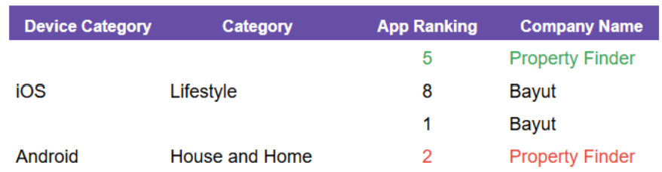

 |  | Weekly |  |  |  | MTD
Category | Metric | Week  (Actual) | Week (Target) | WoW | vs 2 weeks prior | MtD | Month (Target) | vs MtD  prev month (MoM) | vs MtD  prev year (YoY) | vs competition | DRI | Dash
B2C App | DAU | 50.9K |  | (+17%)  43.5K | (-12%)  57.6K | 46.5K |  | (-21%)  58.8K | (-6.4%)  49.7K |  | Amory Kelie
B2C App | WAU | 185.5K |  | (-0.1%)  185.7K | (-18%)  225.8K | 187.6K |  | (-14%)  218.5K | (+4.5%)  179.6K |  | Person

B2C Tech Metrics

B2C App
Category | DRI | Which metric is red and why | Actions planned | ETA for target achievement
App stability & performance | Taran Kambow | - Green
Web Stability & Performance | Amory Kelie | Mobile INP Good Rate reached 72.0%, meeting the target (+2.5pp WoW).The improvement is driven by performance gains across search templates, particularly:  - Search Landing Pages (~26% of traffic)  - Search Results Pages, where we reduced interaction latency significantly  Core templates like Property Listing Pages (~40% of interactions) remain stable and continue to anchor performance.This confirms that performance on search surfaces is the primary driver of overall INP. | Now shift from fixing → sustaining  • Maintain performance stability on search templates (Landing + Results)  • Enforce performance budgets on all high-traffic interaction surfaces  • Tighten governance on experiments and JS injections impacting search  • Continue daily monitoring on top templates to prevent regressions | - Target achieved this week  - Focus now on sustaining ≥72% and progressing toward 75% by end of Q2

 |  | Weekly |  |  |  | MTD
Category | Metric | Week  (Actual) | Week (Target) | WoW | vs 2 weeks prior | MtD  (Forecast) | Month (Target) | vs MtD  prev month (MoM) | vs MtD  prev year (YoY) | vs competition | DRI | Dash
Tech stability & Performance | Mobile INP Good rate (%) | 72.03 | 72 | +2.51 | +1.84 |  |  |  |  |  | Amory Kelie

- Appdex: Android
- Appdex score: iOS
- CWV

B2B Product

B2B
Category | DRI | Which metric is red and why | Actions planned | ETA for target achievement
CSAT  (Incident Volume) | Luis Cappa | March continues with the lowest Incident Volume ever recorded, with only 17 tickets MtD (16 P1s + 1 P0). | N/A | N/A
Agent Experience | Sajjad Ahmad | Conflict-driven dip is easing: WAU rebounded +9.3% WoW, but we’re still below target and not yet back to pre-disruption baseline.  WAU is -33.4% vs target (3,203 vs 4,811) and -9.3% vs two weeks prior (3,590). So last week’s lift is likely a partial recovery from the dip, not a sustained trend yet. | We will rebuild momentum through new feature launches in April, alongside resuming Agent Hour in April, which historically has helped on new users acquisition and WAU.  We will set Q2 targets with the conflict as a planning reality, and track weekly recovery vs this revised baseline (rather than judging against pre-war expectations).

Weekly Metrics
 |  | MTD
Category | Metric | MtD  (Actual) | Month (Target) | vs MtD  prev month (MoM) | vs MtD  prev year (YoY) | vs competition | DRI | Dash
CSAT | Incident Volume | P0: 0  P1: 3 | P0: 6  P1: 73 | P0: 0  P1: 23 | P0: 2  P1: 44 | Not Available | Luis Cappa | Link  (JIRA)

 |  | Weekly |  |  |  | MTD
Category | Metric | Week  (Actual) | Week (Target) | WoW | vs 2 weeks prior | MtD  (Actual) | Month (Target) | vs MtD  prev month (MoM) | vs MtD  prev year (YoY) | vs competition | DRI | Dash

Agent Engagement & Experience | App active agents | 11341 | -16.5%  (vs 13597) | +1.2%  (vs 11201) | +2.12%  (vs 11105) |  |  |  | Not Available | Not Available | Sajjad Ahmad | TBA
 | Active users per week (WAU) | 3203 | -33.4%  (vs 4811) | +9.3%  (vs 2930) | -9.3%  (vs 3590) |  |  |  | Not Available | Not Available | Sajjad Ahmad | TBA
 | Agent NPS | NA | NA | NA | NA | Monthly Metric |  |  |  |  | Sajjad Ahmad | TBA

Agent Engagement & Experience | Agent NPS | Monthly Metric |  |  |  |  | Sajjad Ahmad

Listing Quality

Monetization
Category | DRI | Which metric is red and why | Actions planned | ETA for target achievement
Compliance | Saif Al-Amid | - Main thing to mention is that we managed to reduce violations from DLD by 30%.  - Also we’re working with BA to come up with additional metrics for fake listings [timeline next week call]. | - Launch Locations mandatory (for 100% accurate locations only)  - Size Mandation: mandate size for specific property/permit types  - Prevent listings from be republished  - Fake listings with extremely high/low prices: auto clean up. | - Locations mandation: 26th March  - Size mandation: (delayed) 1.5 week from alignment with listings/b2c teams.  - Republish prevention: 31st March  - Fake listings with extremely high/low prices: auto clean up: 31st March

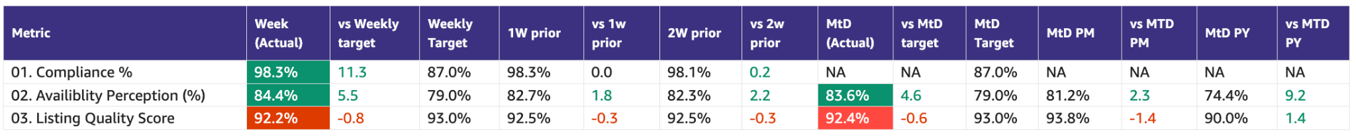

Special Projects
Monthly Lookbacks

Converting at risk clients to Promoters Ivan Gregorc Status
- Expected achievement at the end of the quarter. Based on current progress, what’s the estimated achievement rate for the end of Q1 2025?
By end of Q1, we expect to convert 50%+ of Neutral/Detractor clients into Promoters (target= 15 promoters) and protect renewal risk across the Marketing-owned portfolio (20 clients). Assuming delivery on Product-dependent items.
Current status: 🟢Promoters: 9 🟡Neutral: 9 🔴Detractors: 2
- Achievement (till date) : Indicate completed and pending tasks.
- Client sentiment baseline established and tracked weekly
- Identified top 6 elements to turn Neutral clients into promoters
- Active engagement in place for all Target clients
Pending:
- Impediments : If applicable, what is delaying the progress?
- The majority of blockers are Product-dependent
- Some perception issues (Awards, Premium value) require time and repetition to shift
- Initiatives to address impediments: What actions will we take to address the above issues or improve results?
- 5 out of the 6 (SuperAgent Point System, Spam Leads, Split Deals, Agent Engagements,, Cost of Premium Listings) major issues brought up are being addressed by end March
- 1 out of the 6 (Draft listings Listings) was addressed
Link to deep dive document

Special Projects - Q1 OKRs
Keyper Soumar Aoun On Track
- Expected achievement at the end of the quarter. Based on current progress, what’s the estimated achievement rate for the end of Q1 2025?
  - Keyper integration across B2B and B2C flows is in progress, with the majority of core components in active development and the remaining work focused on final CX workflow alignment and commercial enablement.
Core integration is on track for completion by the end of March. A buffer period for end-to-end testing and launch readiness will follow, with go-live expected no later than 15 April 2025 with overall progress reaching ~95% completion by the end of Q1 2025.
- Achievement (till date) : Indicate completed and pending tasks.
  - 3 agencies selected for MVP launch
  - ~50% of Keyper implementation delivered and the rest is under progress
  - The CX team is working towards a joint CX workflow plan with Keyper.
  - Legal review of key agreements within the flow is ongoing.
- Impediments : If applicable, what is delaying the progress?
  - Design and development capacity constraints have impacted the pace of the integration.

- Initiatives to address impediments: What actions will we take to address the above issues or improve results?
  - Additional contractors onboarded to the B2C team to increase capacity and accelerate delivery
  - Prioritization of core integration components to ensure critical functionality is delivered on schedule

Bundles Paresh Goyal On Track
- Expected achievement at the end of the quarter. Based on current progress, what’s the estimated achievement rate for the end of Q1 2025?
  - MVP Product will be ready for launch in March
  - Pilot sales has been intentionally pushed out, given current market and client situation
- Achievement (till date) : Indicate completed and pending tasks.
  - Development work progressing on-track but with some impact from salesforce migration
- Impediments : If applicable, what is delaying the progress?
  - Salesforce system has just come back online and hence, salesforce development work had paused
  - Expected impact of 2-3 days in completing salesforce development and hence, delay in go-live from 24th March to 26th March
- Initiatives to address impediments: What actions will we take to address the above issues or improve results?
  - Working towards an approach to sign paper contracts for bundles and a potential way to manually switch on bundles for such clients

📋 Prev Saved Reports

Week | Date | Link
Week 11 | Mar 9 to 15 | File
Week 10 | Mar 2 to Mar 8 | WBR - Week 10 (Saved Report) Metric Report
Week 9 | Feb 1 to Feb 28 | WBR - Week 9 - Feb Monthly Lookback (Saved Report) Metric Report
Week 8 | Feb 16 to Feb 22 | WBR - Week 8 (Saved Report) Metric Report
Week 7 | Feb 9 to Feb 15 | WBR - Week 7 (SAVED) Metric Report
Week 6 | Feb 2 to Feb 8 | WBR - Week 6 (Saved) Metric Report
Week 5 | Jan 1 to Jan 31 | WBR - Jan Monthly Lookback (Saved Report) Metric Report
Week 4 | Jan 19 to Jan 25 | WBR - Week 4 (Saved) Metric Report
Week 3 | Jan 12 to Jan 18 | WBR - Week 3 (SAVED) Metric Report
Week 2 | Jan 5 to Jan 11 | WBR - Week 2 (SAVED) Metric Report
Year End.
W52 | Dec 1 to Dec 30 | WBR Metric Report - Dec Monthly Lookback (Saved Report)
W49 | Dec 1 to Dec 7 | WBR Metric Report - Week 49 (Saved Report)
W48 | Nov 1 to Nov 30 | WBR Metric Report - Week 48 - Nov Monthly Lookback (Saved Report)
W47 | Nov 17 to Nov 23 | WBR Metric Report - Week 47 (Saved Report)
W46 | Nov 10 to Nov 16 | WBR Metric Report - Week 46 (Saved Report)
W45 | Nov 3 to Nov 9 | WBR Metric Report - Week 45 (Saved Report)
W44 | NA | NA
W43 | Oct 1 to Oct 31 | WBR Metric Report - Week 43 - Oct Monthly Lookback (Saved Report))
W42 | Oct 15 to Oct 21 | WBR Metric Report - Week 42 (Saved Report)
W41 | Oct 8 to Oct 14 | WBR Metric Report - Week 41 (Saved Report)
W40 | Oct 1 to Oct 7 | WBR Metric Report - Week 40 (Saved Report)
W39 | Sep 1 to Sep 30 | WBR Metric Report - Week 39 (Saved Report)
W38 | Sep 17 to Sep 23 | WBR 2.0 Report - Week 38 (Saved Report)
W37 | Sep 10 to Sep 16 | WBR 2.0 Report - Week 37 (Saved Report)
W36 | Sep 3 to Sep 9 | WBR 2.0 Report - Week 36
W35 | Aug 1 to Aug 31 | Copy of WBR 2.0 Report - Week 35.docx
W34 | Aug 20 to Aug 26 | Copy of WBR 2.0 Report - Week 34.docx
W33 | Aug 13 to Aug 19 | WBR 2.0 Report - Week 33.docx
W32 | Aug 6 to Aug 12 | Copy of WBR 2.0 Report - Week 32.docx
W31 | Jul 30 to Aug 5 | WBR 2.0 Report - Week 31.docx

